# Connect to your Azure MEAN stack using FTP

1. If you haven’t done so already, go to your Bitnami dashboard and download a copy of the .PPK key file.

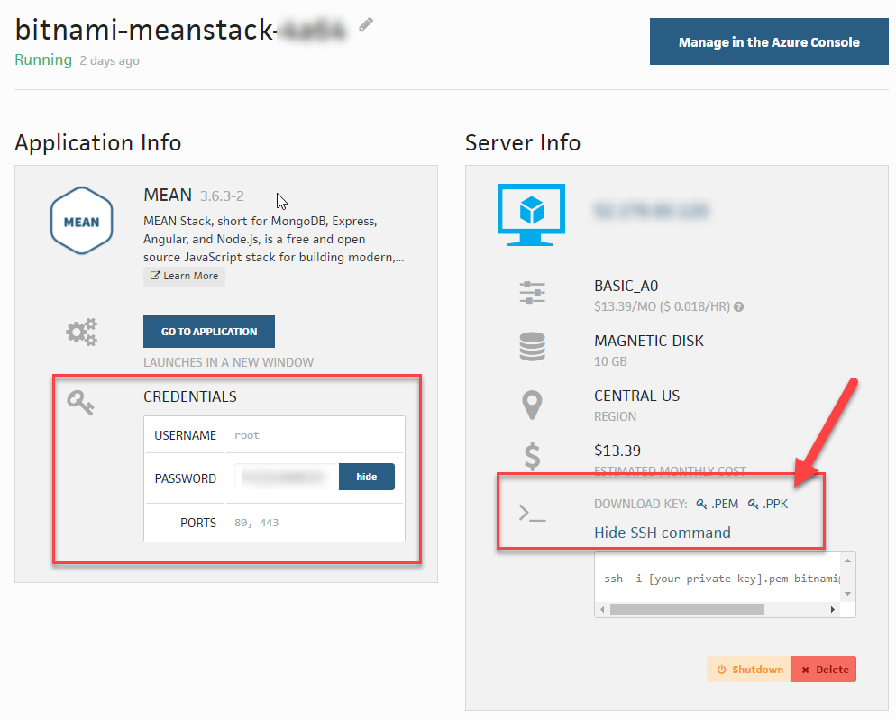

1. Using Filezilla, click on File >> Site Manager >> New Site
2. Host: Enter your site DNS.
3. Port: 22
4. Protocol: SFTP – SSH File Transfer Protocol
5. Logon Type: Key file
6. User: bitnami
7. Key file: Click BROWSE to select the .PPK file from your Bitnami dashboard.
8. Click OK to save your connection.
9. Return to File >> Site Manager and select the connection you just created. Click CONNECT.
10. Once a successful connection has been established, you’ll see your /home/bitnami directory.

